SCIENCE DEPARTMENT

YEAR 11
HUMAN BIOLOGY EXAMINATION
SEMESTER TWO 2005

Student Name: |  |  | Teacher:

Time allowed for this paper
Reading time before commencing work: Ten minutes
Working time for paper: Three hours

section 1: Multiple Choice – 40 Questions – 40 Marks – 40%
Answer the multiple choice questions by crossing out the letter of your choice on the answer sheet provided.
Use a 2B pencil here.

SECTION 2: Short Answers – 10 Questions – 100 marks – 40%
Answer the questions in the spaces provided. Answers are to be in BLUE or BLACK ink.
GRAPHS and DRAWINGS to be in pencil and labelled in ink.

SECTION 3: Extended Answer – 2 Questions – 40 marks – 20%
Answer question 1 OR question 2
AND
Answer question 3 OR question 4.

SECTION 1: MULTIPLE CHOICE 40 MARKS

Mark your answers to questions 1-40 on the separate multiple choice answer sheet, using a 2B pencil. If you make an error, rub out the incorrect choice and put a cross over the correct answer. Also place the new letter choice next to the question number so there is no confusion.

1. Carbon dioxide travels:

- as gas bubbles in the plasma.
- partly in the red blood cells and partly dissolved in the plasma as bicarbonate ions [HCO₃ ⁻ ].
- in the white blood cells.
- entirely in the red blood cells.

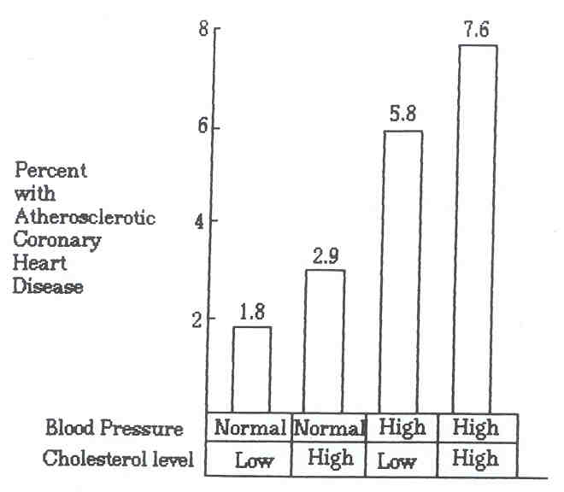

2. The graph above shows:

(a) the most important factor contributing to atherosclerosis is the amount of cholesterol in the blood.
(b) high blood pressure and low cholesterol contributes more to atherosclerosis than high cholesterol.
(c) atherosclerosis is more likely with high blood pressure and high cholesterol.
(d) high blood pressure is the only factor which is implicated in atherosclerosis.

3. When air is inhaled it flows through an air tube system to reach the air sacs. The system consists of the following:

(i) larynx (iv) bronchi
(ii) bronchioles (v) trachea
(iii) pharynx (vi) nasal cavity

What order does it follow?

A | B | C | D
nasal cavity  trachea  bronchi  pharynx  bronchioles  larynx | nasal cavity  bronchi  larynx  trachea  pharynx  bronchioles | nasal cavity  pharynx  larynx  trachea  bronchi  bronchioles | nasal cavity  bronchi  bronchioles  trachea  pharynx  larynx

(a) A.
(b) B.
(c) C.
(d) D.

4. During the process of expiration the:

(a) diaphragm lowers.
(b) ribs move upward and outward.
(c) size of the thoracic cavity increases.
(d) pressure inside the thoracic cavity increases.

5. Which of the following is true of gaseous exchange through the wall of the alveolus?

(a) Nett diffusion of oxygen is from alveoli to the blood capillaries.
(b) Nett diffusion of carbon dioxide is from alveoli to the blood capillaries.
(c) Diffusion of oxygen occurs at the same rate in both directions.
(d) Diffusion of carbon dioxide occurs at the same rate in both directions.

6. Supplemental (expiratory reserve volume) air is that which:

(a) we can inhale by making an extra effort.
(b) we can forcibly exhale after normal exhalation.
(c) remains in the lungs after all other air has been forced out.
(d) is given to deep sea divers as an emergency supply.
7. The following table shows the composition of inhaled and exhaled air.

 | Inhaled Air | Exhaled Air
Oxygen | 20.7% | 14.8%
Carbon dioxide | 0.04% | 4.3%
Nitrogen | 79.0% | 79.5%
Water vapour | Same as atmosphere | Higher than atmosphere
Temperature | Same as atmosphere | Higher than atmosphere

Which of the following statements are TRUE?

A Exhaled air has a lower concentration of oxygen but a higher concentration of carbon dioxide and water vapour.
B The carbon dioxide content in exhaled air is increased 100 times due to excretion as waste through the alveoli.
C The water vapour in exhaled air is derived from the evaporation along the respiratory tract.
D The temperature of the exhaled air is higher because the air is warmed by the surrounding air near the nostrils.

(a) A and C only.
(b) A, B, C, D.
(c) B and D only.
(d) A, B and C.

8. When air is inhaled it flows through the air tube system to reach the air sacs. Which labelled part of the system contains the vocal cords?

Air tube system

Larynx Bronchioles Pharynx Bronchi Trachea Nasal cavity
A B C D E F

(a) A.
(b) B.
(c) C.
(d) D.

9. Many children in Australia suffer from asthma. Wheezing in asthma would be directly produced by:

(a) constriction of the bronchi and bronchioles.
(b) grass pollens in the air.
(c) mucus obstructing the nasal passages.
(d) atmospheric pollution.
10. Which of the following methods of “contraception” operates largely by preventing implantation rather than by preventing fertilization?

(a) Diaphragm.
(b) Intra-uterine device.
(c) The “pill”.
(d) Condom.

11. The structures in the following diagram labelled A and B are the

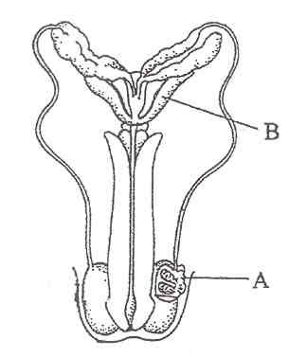

(a) urethra and vas deferens.
(b) epididymis and prostate.
(c) seminal vesicle and foreskin.
(d) scrotum and vas deferens.

12. During the time that a foetus is developing inside the uterus

(a) it uses food that has been stored in the placenta.
(b) it is nourished via the umbilical cord.
(c) it uses food stored in a yolk.
(d) it is supplied with nutrients from the amniotic fluid.

13. The foramen ovale is found

(a) in the inferior vena cave.
(b) in between the right and left atrium.
(c) in the aorta.
(d) in between the left ventricle and the left atrium.

14. The hormone responsible for the ‘let down’ reflex is

(a) oxytocin.
(b) progesterone.
(c) prolactin.
(d) oestrogen.

15. Using the table below, the average height gained by a female between the ages of 1 year and 2 years of age is

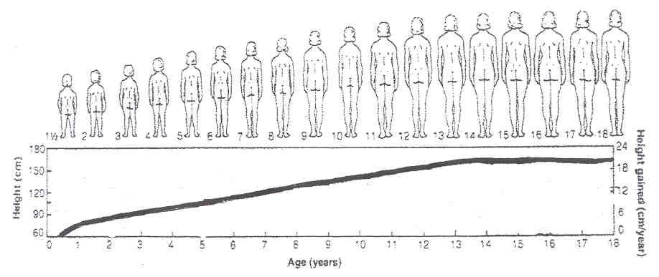

(a) 3 cm.
(b) 4 cm.
(c) 5 cm.
(d) 6 cm.

16. Amniotic fluid is important by serving as a medium

(i) for providing nutrients to the embryo.
(ii) to provide constant temperature surrounding the embryo.
(iii) to act as a shock absorber for the embryo.

(a) (i) only.
(b) (i) and (ii) only.
(c) (ii) and (iii) only.
(d) (i), (ii) and (iii).

17. The development into sexual maturity is termed

(a) adolescence.
(b) puberty.
(c) growing pains.
(d) maturity.

18. As a person ages, various parts of their body begin to change. Which of the following does NOT occur as a person ages?

(a) Lung capacity decreases.
(b) Joints become less mobile.
(c) An increase in kidney functioning leading to increased volumes of urine.
(d) A decrease in fat content of the body especially under the skin.

19. Which of the following best describes the second stage of the dying process?

(a) Body temperature falls and disintegration occurs.
(b) Muscles contract and the heart stops beating.
(c) The pupils dilate and the person urinates.
(d) The brain loses consciousness.

20. By which method are the genetic disorders Down Syndrome and Muscular Dystrophy detected?

(a) X-ray.
(b) Fetoscopy.
(c) Amniocentesis.
(d) Oogenesis.

21. The diagram below shows three stages in human development. The proportions have been made equal.

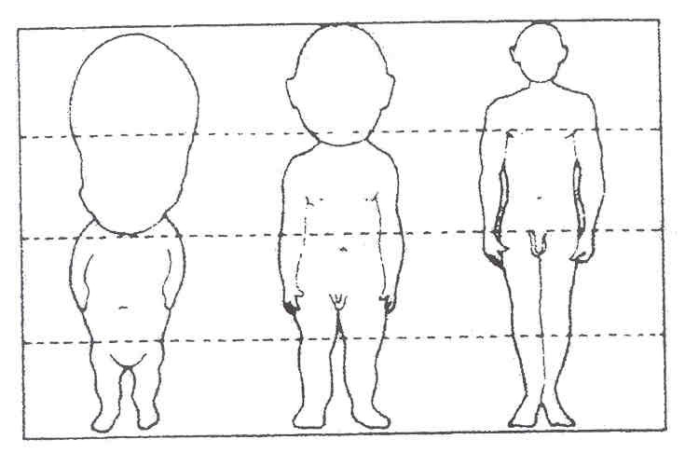

Which is the UNTRUE statement?

(a) The length of the legs increases in proportion to the body.
(b) The parts of the body develop at different rates.
(c) The head is shrinking.
(d) The arms increase in proportion to the body.
22. The following table shows deaths during infancy (first 9 months) related to types of feeding. (Statistics gathered in a third world country during the 1950’s).

Food | Number of Infants | Total Deaths | Death Rate
Wholly breast fed | 9000 | 9 | 0.15
Partially breast fed | 3000 | 45 | 1.5%
Fed artificial formula | 6000 | 270 | 4.5%

From the table above, the death rate amongst infants fed on artificial formula is

(a) 6.0 times greater than that for partially breast fed infants.
(b) 30.0 times greater than that for wholly breast fed infants.
(c) 4.0 times greater than that for partially breast fed infants.
(d) 45.0 times greater than that for wholly breast fed infants.

23. Which of the following statements about ageing is NOT true?

(a) Decreased output and blood flow by circulation is often coupled with respiratory and kidney failure in elderly people.
(b) Ageing is generally first noticed by changes to the skin, muscle wasting, a tendency to slower reactions and slower healing rate when tissue is damaged.
(c) All body cells, including nerve and muscle cells, are capable of replication for a limited time only; cells that exceed this life span will eventually die.
(d) Greying hair, menopause, wrinkles and diminishing athletic ability are possible visible signs of the work of ageing genes.

24. Rapid, repeating uterine contractions responsible for dilation of the cervix prior to birth are better known as

(a) labour pains.
(b) peristalsis.
(c) Braxton hicks pains.
(d) all of the above.

25. Amino acids resulting from the digestive breakdown of protein are mainly absorbed in the

(a) stomach.
(b) pancreas.
(c) small intestine.
(d) large intestine.

26. Which of the following statements about the development of the fertilised ovum is INCORRECT?

(a) Fertilisation produces a zygote which contains 46 chromosomes.
(b) The fertilised ovum undergoes several mitotic divisions.
(c) The morula develops a cavity and becomes a blastocyst.
(d) The blastocyst implants in the endometrium 3 weeks after fertilisation.

27. The first sign of syphilis is usually

(a) a small copper coloured rash at the site of contact.
(b) benign growths occurring randomly in the body.
(c) white ulcers in the mouth.
(d) superficial sores at the site of contact.

28. Which of the following statements about pregnancy is INCORRECT?

(a) During late pregnancy women urinate more often because the expanding uterus exerts pressure on the bladder.
(b) The lungs of the foetus are collapsed until birth.
(c) The chorion is made from the mother’s cells.
(d) The umbilical vein carries oxygenated blood from the placenta to the foetus.

29. Digested lipids would be in the form of

(a) amino acids and glucose.
(b) glucose and glycerol.
(c) fatty acids and sucrose.
(d) fatty acids and glycerol.

30. Which is NOT a function of saliva?

(a) Lubricates the mouth.
(b) Contains antibodies that kill bacteria.
(c) Dissolves food so the taste receptors can be stimulated.
(d) Mechanical digestion.

31. Fertilisation in humans means

(a) release of an egg from the ovary.
(b) placing of the penis into the vagina.
(c) fusing of the sperm with an egg.
(d) discharging sperms at the cervix.

32. Which of the following does NOT describe a spermatozoon?

(a) A motile cell.
(b) A single cell with an ovoid-shaped head, a small middle piece and a tail.
(c) Single cell containing 46 chromosomes.
(d) Produced by the testis.

33. Cardiovascular disease is presently the most serious health problem in Australian society. The commonest cause of this disease is hypertension (high blood pressure). Which of the following suggestions is recommended to prevent hypertension?

(a) Moderately smoking, drinking and eating anything.
(b) Regular exercise and a careful dietary program.
(c) Limiting energy and salt intake, regular daily exercise, relaxation sessions and no smoking.
(d) None of the above.

34. The main function of the large intestine is

(a) absorption of bile.
(b) absorption of fatty acids and glycerol.
(c) Absorption of water.
(d) Absorption of blood.

35. Which of the following is a method that cannot lead to the spread of HIV?

(a) Having unprotected sex.
(b) Blood transfusions in countries where blood is not tested.
(c) Toilet seats in public toilets.
(d) Sharing needles and syringes.

36. In mammals, most enzymes cease to function when they pass from one part of the alimentary tract to another. Which one of the following statements is the most likely explanation for the generalisation?

(a) Different substrates require a variety of enzymes.
(b) Enzymes are affected by temperature changes.
(c) Some enzymes will only operate in a relatively narrow pH range.
(d) Absorption of the products of digestion has occurred and enzyme reaction is no longer necessary.
Graph showing growth rates of human organ systems

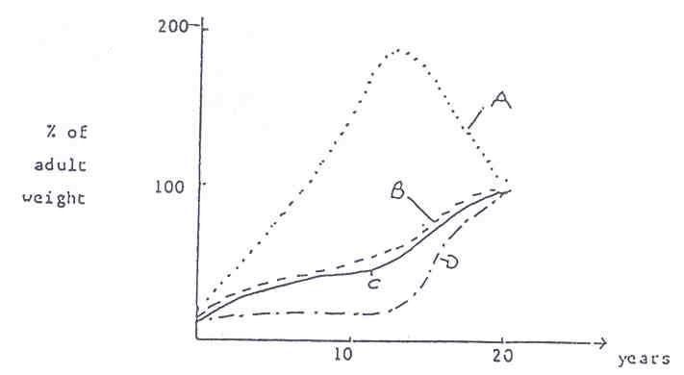

37. In the graph above, line A and D represent respectively, growth of

(a) the reproductive and nervous systems.
(b) the immune and nervous systems.
(c) cartilage in the skeleton and total body weight.
(d) the immune and reproductive systems.

38. The milk secreting regions of the human breast are called

(a) lobes.
(b) lobules.
(c) alveoli.
(d) areola.

39. Which of the following contains a body part that is not involved in digestion?

(a) Stomach, liver and gall bladder.
(b) Gall bladder, liver and colon.
(c) Stomach, duodenum and liver.
(d) Stomach, trachea and liver.

40. A guide to whether an individual is overweight is calculated using the body mass index. This is calculated in the following way.

BMI | = | weight (kg)
BMI | = | height x height (m)

To interpret the results a standardised chart has been constructed.

Condition | BMI
Underweight | 19.9 or less
Acceptable weight | 20 - 25
Overweight | 25.1 - 30
Obese | 30.1 - 40
Extreme obesity | 40.1 or more

If a 1.57m woman weighed 63kg, into which category would she fall?

(a) Underweight.
(b) Overweight.
(c) Acceptable weight.
(d) Obese.

END OF MULTIPLE CHOICE SECTION

SCIENCE DEPARTMENT

YEAR 11
HUMAN BIOLOGY EXAMINATION
SEMESTER TWO 2005

Student Name: |  |  | Teacher:

SECTION 2: Short Answers – 10 Questions – 100 marks – 40%
Answer the questions in the spaces provided. Answers are to be in BLUE or BLACK ink.
GRAPHS and DRAWINGS to be in pencil and labelled in ink.

SECTION 2: SHORT ANSWER SECTION 100 MARKS
Fill in all answers in this booklet.
Spelling and grammar will count towards your mark.
This section is worth 40%.
Good luck.

41. Refer to the following diagram.

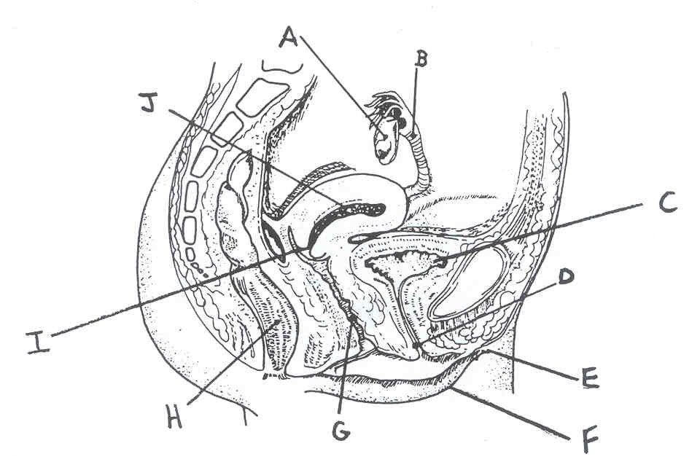

(a) Give the name and function of parts labelled D, J and G. (3 marks)

D
J
G

(b) Explain the event associated with organ A every month. (2 marks)

(c) The process of female sterilization involves which part on the above diagram?
(1 mark)

(d) Each ejaculation of a healthy, fertile male contains 100-400 million sperm. State why so many sperm are needed. (1 mark)

(e) With reference to the following diagram, what do the labels represent? (5 marks)
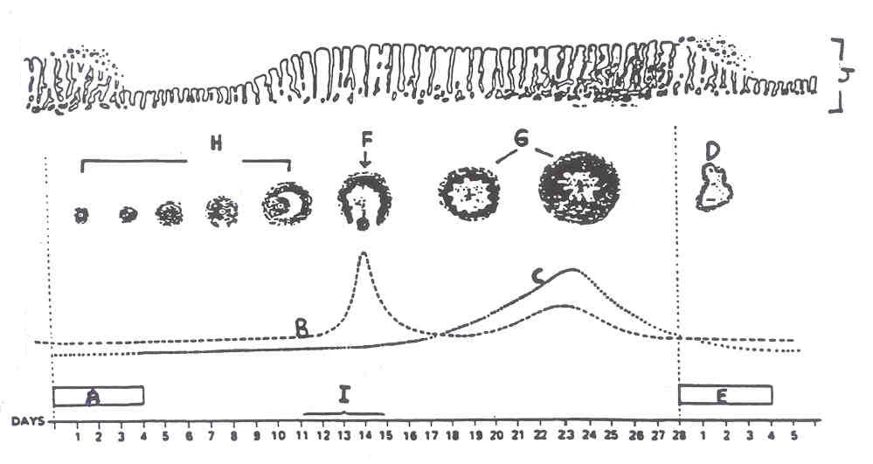

A. |  | F.
B. |  | G.
C. |  | H.
D. |  | I.
E. |  | J.

(f) The four major hormones involved in the female cycle are listed below. For each hormone, explain when it is produced during the menstrual cycle, where it is produced and its action. (6 marks)

Hormone | Site of Production | When (days) | Effect
LH
FSH
PROGESTERONE
OESTROGEN

42. Number of notified cases of Gonorrhoea and Syphilis in Western Australia for the years 1985-1996.

Year | Gonorrhoea | Syphilis
1985 | 1700 | 380
1986 | 1580 | 290
1987 | 1080 | 300
1988 | 1030 | 250
1989 | 750 | 260
1990 | 730 | 200
1991 | 720 | 285
1992 | 850 | 350
1993 | 830 | 170
1994 | 850 | 120
1995 | 860 | 100
1996 | 870 | 90

(a) Plot the results on a line graph. (5 marks)

(b) Give an explanation for a drop in both diseases in the early 1990s. (1 mark)

(c) Complete the following table. (3 marks)

 | Gonorrhoea | Syphilis
Cause
Symptoms
Treatment

(d) Teratogens are substances that cause malformations in embryonic
development. (4 marks)

(i) Give a general explanation why substances ingested by the mother have the potential to be harmful to the foetus.

(ii) Explain why cigarette smoking is so harmful to foetal development.

43. (a) Describe the changes to the foetal circulatory system at birth. (6 marks)

(b) What is the benefit of long infant dependency. (1 mark)
44. (a) Label the following diagram. (7 marks)

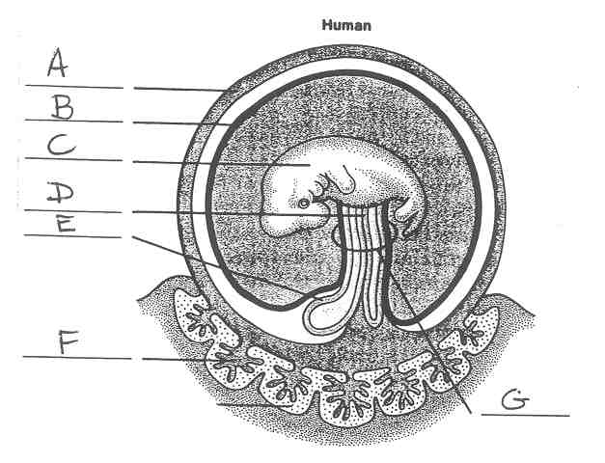

A. |  | E.
B. |  | F.
C. |  | G.
D.

(b) Explain what is meant by cleavage and comment on its significance to the early development of the embryo. (2 marks)

(c) Explain the purpose and importance of the amniotic sac to the developing embryo. (2 marks)

(d) Complete the following table. (4 marks)

 | Advantages | Disadvantages
breast | 1. | 1.
FEEDING | 2. | 2.
BOTTLE | 1. | 1.
FEEDING | 2. | 2.

(e) Describe, in reference to developmental milestones, how you would distinguish between a 2 month old baby and a 6 month old baby. (3 marks)

(f) List and briefly describe the three patterns involved in motor development.
(3 marks)

(i)

(ii)

(iii)

45. (a) A hormone secreted by the anterior pituitary that stimulates the production of milk from the mammary glands.

(b) An early stage of embryonic development that consists of a hollow ball of cells.

(c) Name the process that gives rise to the primary spermatocyte.

(d) The period of time at which sexual maturity is reached.
(e) The period of time in a woman’s life when her ability to reproduce comes to an end.

(f) Name the hormone that controls sperm production.

(g) The study of ageing.

(h) A place where the dying are cared for. (4 marks)

46. (a) The testes develop in the abdominal cavity then descend into the scrotal sac. Why is it necessary for the testes to descend into the scrotum? (1 mark)

(b) Vasectomy is an operation used to sterilise men. Explain what structures are operated on and how the technique prevents conception. (2 marks)

(c) Why is castration an unsuitable procedure for male sterilisation? (1 mark)

47. (a) Study the diagram of the digestive system below and provide labels for the structures listed. (5 marks)

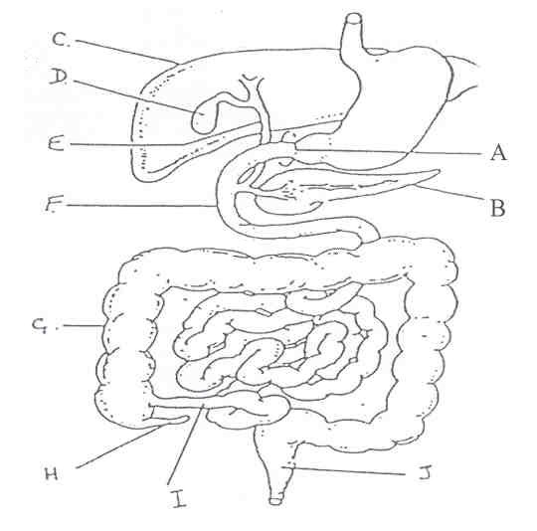

A.
B.
C.
D.
E.
F
G
H
I
J

(b) Give the functions of structures D and I. (2 marks)

D
I

(c) Explain why little or no carbohydrate digestion occurs in the stomach. (1 mark)

(d) Explain the role of the pancreas in lipid digestion (1 mark)

(e) Give two functions of structure C other than the production of bile. (2 marks)

(f) Label the diagram below of a villus. (4 marks)
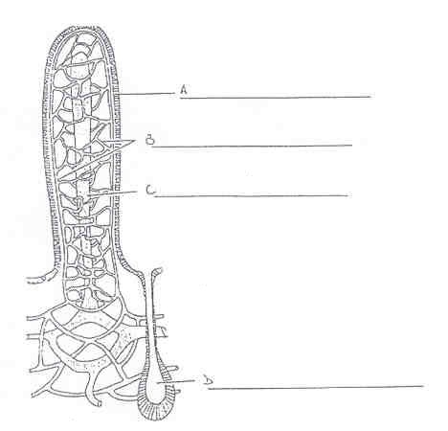

(g) Describe two ways a villus helps in the absorption of digested food. (2 marks)

(i)
(ii)

(h) Name and describe the process used to move food through the alimentary canal.
(2 marks)
48. The diagram below shows motor development after birth. (2½ marks)
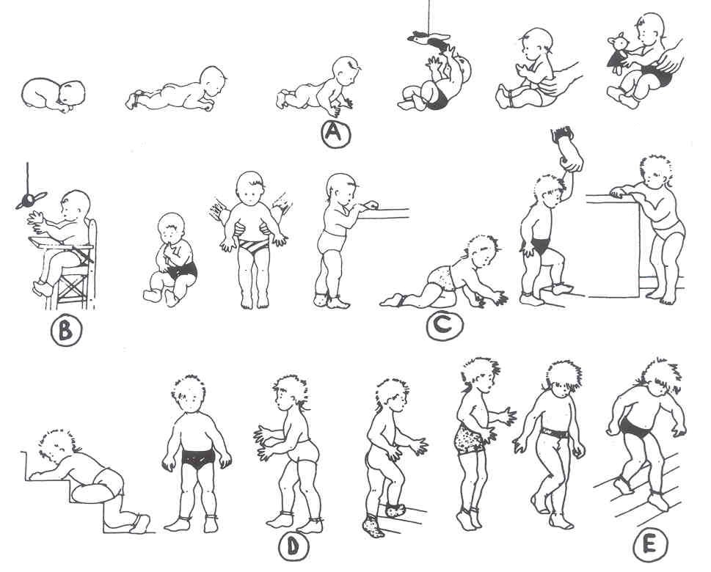
Give the ages of the children shown on the diagrams as A, B, C, D and E.

A
B
C
D
E

49. Refer to graphs A and B below which show changes in height and weight of children between 4 and 18 years of age.

A – BOYS B - GIRLS
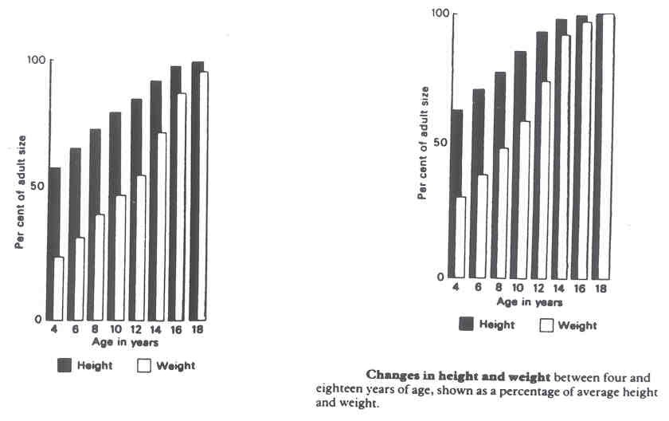

(a) Which sex reaches approximately 50% of adult body weight first? (1 mark)

(b) At what age does this occur? (1 mark)

(c) At what age do boys reach 98% of adult height? (1 mark)

(d) At what age do girls reach 70% of adult weight? (1 mark)

50. Label the following diagram below. (3 marks)

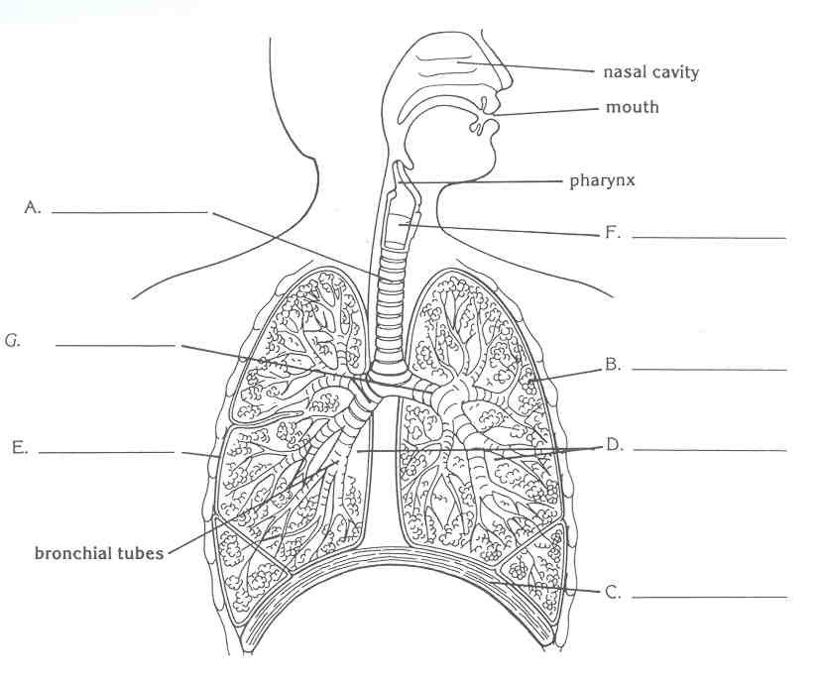

A.
B.
C.
D.
E.
F

(b) What is the name of the space in which the heart lies? (1 mark)

(c) What is the name of the fluid covering B? (1 mark)

(d) What is the function of C? (2 marks)

(e) What structure usually prevents food entering structure A? (½ mark)

END OF SHORT ANSWER SECTION

SCIENCE DEPARTMENT

YEAR 11
HUMAN BIOLOGY EXAMINATION
SEMESTER TWO 2005

Student Name: |  |  | Teacher:

SECTION 3: Extended Answer – 2 Questions – 40 marks – 20%
Answer question 51 OR question 52
AND
Answer question 53 OR question 54.

SECTION 3: Extended Answers 40 MARKS

Fill in the answers to your essays in this booklet.
Number your questions appropriately.
All answers are to be written in blue or black biro pen.
Diagrams are to be done in pencil with labels.
Spelling and grammar count towards your final mark.
Good luck!

PART A

ANSWER EITHER QUESTION 51 OR QUESTION 52 – NOT BOTH

QUESTION 51

(a) Describe the changes that take place in the body proportions over the first five years of life, with special reference to

(i) the head
(ii) the trunk
(iii) the limbs (10 marks)

(b) Discuss the changes that occur to a young person’s body during puberty. (6 marks)

(c) Discuss the changes that occur to four (4) body systems in old age. (4 marks)

OR

QUESTION 52

One day, while at the beach, you notice a person on the shore having difficulty with their breathing. The person’s breathing deteriorates to such an extent that you decide to go to their aid and apply expired air resuscitation.

(a) Outline the steps you would take in giving expired air resuscitation. (10 marks)

(b) You are successful in your attempts to revive the person but later ponder why it was possible to revive someone with expired air. Explain how this is possible. (2 marks)

(c) Describe the adaptations of the respiratory structures which make them such an efficient gas exchange system. (8 marks)

AND
PART B

ANSWER EITHER QUESTION 54 OR QUESTION 55 – NOT BOTH

QUESTION 53

(a) The human body uses a number of hormones that are released for reproduction. Explain in detail the hormones released, the effects of each one and the target organ. (12 marks)

Examine the diagram below.
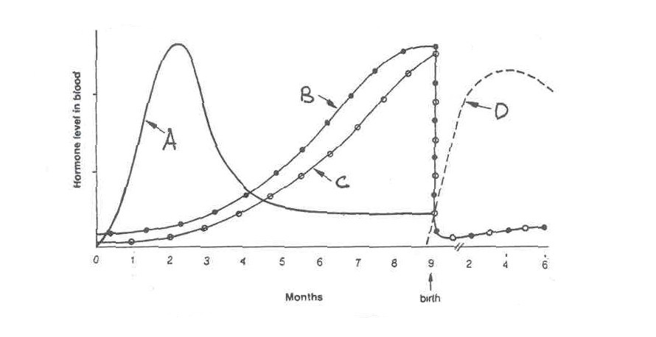

(b) Identify and correlate the trends of hormones A – D with the stages of reproduction in the human body. (4 marks)

(c) Explain how the milk let-down reflex is used in taking care of a newborn baby. (4 marks)

OR

QUESTION 54

Outline five (5) different methods of birth control which are available.

Discuss in your answer:

(a) the mechanisms by which each method works or is thought to work. (7 marks)
(b) the effectiveness of each of these methods. (5 marks)
(c) the side effects of each these methods. (5 marks)
(d) cultural factors preventing the widespread use of certain methods in some countries.
(3 marks)

